

**Vol. 3 No. 1 (2025)**

**JOURNAL OF POLITICAL STABILITY ARCHIVE**

**Online ISSN:** 3006-5879 **Print ISSN:** 3006-5860

[**https://journalpsa.com/index.php/JPSA/about**](https://journalpsa.com/index.php/JPSA/about)

**Recognized by:** Higher Education Commission (HEC), Government of Pakistan

**Integrating Agriculture and Tourism in Khyber Pakhtunkhwa: Building a Sustainable Ecosystem for Growth**

**Dr. Mohammad Alam**

Assistant Professor**,** Department of Tourism & Hospitality, Hazara university, Mansehra KP, Pakistan

[alampices@gmail.com](mailto:alampices@gmail.com)

**Huzaifa Ahmad Khan**

MPhil Scholar**,** Department of Tourism & Hospitality, Hazara university, Mansehra KP, Pakistan

[huzaifa6103@gmail.com](mailto:huzaifa6103@gmail.com)

**Muhammad Zahid**

Visiting Lecturer**,** Department of Tourism and Hotel Management, University of Swabi, KP, Pakistan

[mzahid9689@gmail.com](mailto:mzahid9689@gmail.com)

|  |
| --- |
| **ABSTRACT**  Agritourism is the practice of visiting real farmland or other farming enterprises for entertainment, knowledge, or active participation. This is becoming one of an important components of economic growth in rural communities and sustainable rural development. Khyber Pakhtunkhwa (KP) is a famous destination for tourists in Pakistan, renowned for its rich agrarian and cultural legacy, as well as its diversified geographical terrain. These diverse features offer exclusive opportunities for agritourism. Agritourism has the potential to be a driving force for improvement in the rural environment of the province. This article examines the potential for agritourism, or the blending of agriculture with tourism, in KP. Agritourism has been cited as a potential replacement for conventional farming which can increase farm income, product revenue, and rural community empowerment. The integration of agricultural practices with tourism, known as agritourism, presents a substantial opportunity for rural development, especially in areas such as Khyber Pakhtunkhwa (KP), Pakistan. Through an analysis of available data, previous and case studies, agritourism practice can make positive changes when agriculture is practice and adopted as profession in communities. Through these studies, we highlighted the role of agritourism in promoting sustainable development, preserving cultural heritage, and enhancing the livelihoods of rural populations.  **Keywords:** Agritourism, alternative agriculture, Farmstay, Rural development, Food security. |

**INTRODUCTION**

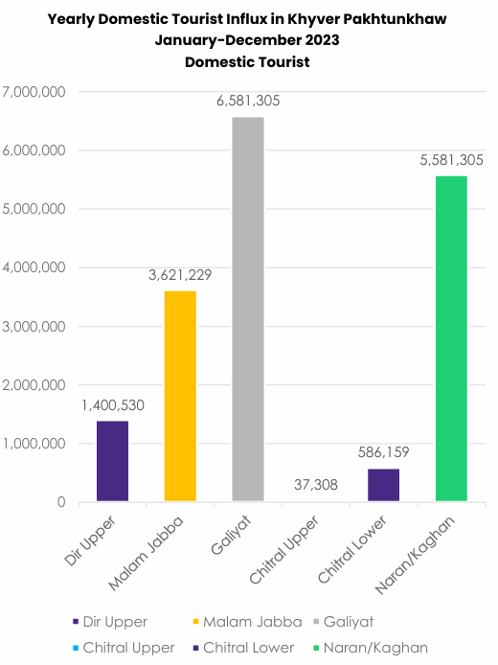The main results from the WTTC's current annual research for 2024 show that in the year 2023, the travel and tourism industry generated 9.1% of global GDP, rising 23.2% from 2022. This sector produced 330 million jobs in 2023, with a 10% increase over 2022. According to the WTTC's 2024 research findings on tourism in Pakistan, 5.8% of the nation's GDP was earned from the travel and tourism industry in 2023 with a substantial 8.7% rise from 2022. In addition, the industry supported 4.73 million jobs in 2023 or 6.7% of the total jobs in the entire country (PTDC, 2024). It is important to state that with 26% of the country's GDP, 45% of the labor force employed, and 67% of the population either directly or indirectly supported by agriculture, it is one of Pakistan's most important economic sectors (Chaiya, C., et al. 2023).

**Figure 1:** Pakistan Tourism barometer (2023-24)

Khyber Pakhtunkhwa (KP) is a favorite vacation spot for both domestic and foreign travelers due to its wide range of scenic splendor, long history, and rich cultural legacy. some of the most breathtaking natural resorts in the nation, including the Galliyat area, Kaghan, Chitral, Naran, and Swat. According to the report, 16.9mn tourists, including 4,554 foreigners, visited Khyber Pakhtunkhwa (KP) in 2023 (Naveed, S, 2024). Over the Eid holidays in 2021, two to three million people travel to KP and the northern districts, generating the province an estimated Rs four billion. A growing trend in the world of sustainable development, agritourism is a subset of rural tourism that helps both the travel industry and agriculture. By enabling tourists to interact with farm life and discover the countryside, it improves tourism experiences while giving farmers more revenue. Agritourism in Pakistan, especially in Khyber Pakhtunkhwa, provides an ideal opportunity to boost regional economies, conserve cultural heritage, and conserve the environment.

**Aim of the study**

This study aims to

* Identify characteristics of agritourism
* To identify the relationship between farm characteristics and the performance of agritourism among farms diversified into tourism.
* To identify how Agritourism farms often involve tourism business overlaps

**LITERATURE REVIEW**

Agritourism was first used in the US in the beginning of the nineteenth century, often known as agritainment (Karabati et al., 2009). The literature employs several terminologies that overlap, such as agrotourism, agriculture tourism, farm tourism, farm-based tourism, and rural tourism. Therefore, it is important to define agritourism and its many forms to fully comprehend the concept. The kind is often determined by three things: the authenticity of the experience, the sort of tourist involvement with farming, and if the product is produced on a functioning farm (Phillip, S., Hunter, C., & Blackstock, K. (2010). To further develop their social and economic advantages, many small farms are turning more and more to non-agricultural initiatives like tourism, which is an attractive choice worldwide (Choo, H., & Park, D. B. 2022). There are three categories for agritourism in Italy: farm with light meals, farm with full-service meals, and full-service farm vacations. In addition to value-added agricultural products, farmers are permitted to sell locally produced wines, olive oils, pasta, meats, cheeses, honey, baked goods, and handicrafts (traveloregon:2017). Although agritourism is becoming more popular in many Asian nations, most of the literature concentrates on North American and European case studies (Yinga, T., & Zhou, Y. 2007)). An increasing volume of demand-side elements has contributed to the recent boom in agritourism, but market demand due to high disposable income, desire for novel holiday experiences in rural areas, has propelled the agritourism appeal (McGehee, N. G., & Kim, K. 2004; Tchetchik, A., Fleischer, A., & Finkelshtain, I. 2008). Agritourism in underdeveloped nations must be approached differently than in developed nations, requiring greater marketing and public education tailored to the socioeconomic circumstances of the target audience (Lak, A., & Khairabadi, O. 2022). Although tourism has a major direct impact on certain farms, for many it has a secondary effect that predominantly increases sales of agricultural products (Barbieri, C., & Mshenga, P. M. 2008). Many farms use agritourism as an integral strategy, providing leisure and hospitality activities to increase revenue, draw tourists, and promote rural living, it's regarded as a good choice for diversity on-farm (Khanal, A. R., Honey, U., & Omobitan, O. 2020). In India with its popular "Home Stay Scheme," the Himachal Pradesh government has introduced a new initiative called "Har Gaon Ki Kahani," which means "story of every village."to  draw tourists to the less popular and isolated rural locations (Krishna, D. K., & Sahoo, A. K. (2020). Activities related to agritourism can vary from large-scale events planned by companies such as hotels and restaurants to small-scale family-run businesses like farm stay or homestays in rural destinations. It functions as an economic activity that boosts the GDP of the nation and provides farm owners with revenue (Lak, A., & Khairabadi, O. 2022). The state governments of Karnatika UP, and Rajisthan made the decision to incorporate agritourism in their tourism policies, and Keralan villages came up with the creative idea of "Farm Tourism." (Krishna, D. K., & Sahoo, A. K. 2020).  Most small farmers worldwide 87% live in Asia and the Pacific, with Pakistan accounting for 58% of all smallholder farmers with land under two acres. Just 16% of the land is farmed by these smallholders; 37% is farmed by individuals who own more than 10 acres (Saqib, S. E., et al. 2017). Veljković, B., & Broćić, Z. (2017) believe that the combining conventional farming with non-agrarian pursuits may support rural communities' sustainable development while the goal of integrated rural development is to safeguard the environment and people while developing rural regions in a sustainable manner. The EU's Common Agricultural Policy (CAP) introduces measures to protect the environment and encourage integrated farming through its reforms.

**METHODOLOGY**

This study employed secondary data from many publications, journals, and online sources on agriculture, tourism, and agritourism, as well as some findings from other writers who have conducted research on this subject. This study is inspirational methodology adopted by Barbieri, C. (2020) to provides the future of agritourism places and research, based on the existing literature and current developments in agriculture and tourism.

**Agricultural landscape of Khyber Pakhtunkhwa**

Pakistan is a major producer of fruits and vegetables and around 29 types of fruits and 33 types of vegetables are produced in the country. Pakistan’s share in total global trade in horticulture commodities is around 0.3 percent. Khyber Pakhtunkhwa, where agriculture is a one of the primary economic activities, with 31% small scale farmers, 50% Medium scale farmers and 19% large scale farmers see Figure 2.

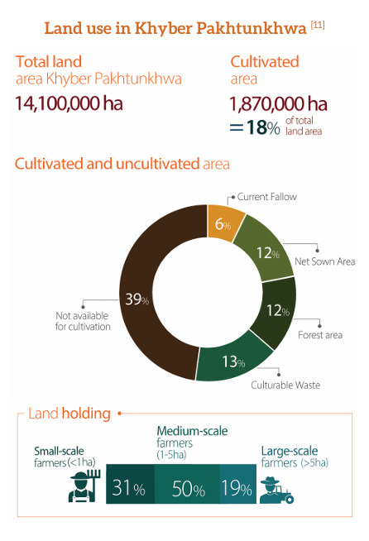

**Figure 2:** Land use in KP

Khyber Pakhtunkhwa (KP) has 1.87 million hectares under cultivation, making up 18% of its land use and 8.4% of Pakistan's agricultural area. Agriculture employs 33% of the province's workforce, but the region faces food security challenges. Of the 35.5 million population, 97% live in rural areas, including merged regions, and 27% live below the national poverty line of $3.10/day (Miller, V, *et al.,2021).)* Agritourism presents a unique opportunity to boost local economies, preserve indigenous cultures, and promote environmental conservation. Khyber Pakhtunkhwa province presents a unique opportunity for the development of agritourism, a niche tourism sector that combines agriculture and tourism. The region is characterized by a diverse landscape, rich in natural resources and traditional agricultural practices, which can serve as a draw for tourists seeking to immerse themselves in the local culture and Experience.

The province's natural beauty, including its towering mountains, lush valleys, and pristine rivers, offers a picturesque backdrop for agritourism activities. KP long history of agricultural production—particularly in horticulture and livestock farming highlights the province's potential for agritourism (see Table:1).

The capacity of agritourism in KP to support local people economically while protecting the area's natural and cultural heritage is one of its main benefits. By promoting the farms, encouraging recreational usage, and even boosting the local economy, agritourism may help family farms remain in operations while optimizing the efficiency of farming resources. A synergistic link between the tourist business and the agricultural sector may be created by integrating the region's different produce, such the fruits and vegetables (see Table 3) into the visitor experience (Torres, R., & Momsen, J. (2011). However, the development of agritourism in PK is not without its challenges.

**Agritourism in Khyber Pakhtunkhwa: A Contextual Overview**

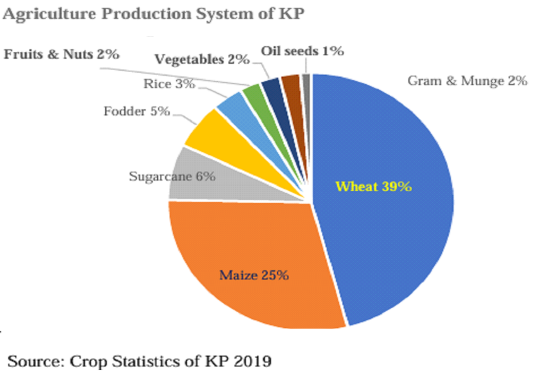Khyber Pakhtunkhwa, located in the northern region of Pakistan, is endowed with diverse agro-ecological zones, ranging from fertile plains to mountainous terrains. Agriculture forms the backbone of the region's economy, with a significant portion of the population engaged in farming activities. The province's rich cultural heritage, coupled with its scenic landscapes, makes it an ideal location for developing agritourism. Farm-tourism activities are given in table No:2 Despite these potentials, agritourism remains underdeveloped in KP due to several challenges, including lack of awareness, inadequate infrastructure, lake of training, branding of farms and limited government support.

**Figure 3**: KP agriculture production

In the last twenty years, there has been a significant increase in the commercial production of fruits and vegetables, as recognized by the Government of KP's Agricultural Policy. KP agroclimatic conditions, which include the merged districts, offer significant prospects for high-value crops, particularly horticulture. A smaller area is farmed during the Rabi season (8,869 ha), but the majority of fruits and nuts produced in KP are grown during the kharif season (36,255 ha). Apples, peaches, musk melon, persimmon, plums, apricot, dates, walnut pears, guava, watermelon, banana, mango, pomegranate, almond, grapes, and figs are among the main fruits and vegetables grown in KP. Vegetables are grown in Khyber Pakhtunkhwa during both the Rabi and Kharif seasons. 22,651 hectares are covered in kharif vegetables such as lady fingers, tinda, brinjal, pumpkin, and the bitter gourd are cultivated on 15,524 hectares. The main vegetable-producing districts include Swat, Charsadda, Peshawar, Mardan, Nowshera, and D.I. Khan (KP Crop Statistics, 2018-19) see table no.1. A total of over 62,286 hectares are sown with rice during the Kharif season. This crop is only produced in regions with irrigation, mostly in the districts of D.I. Khan, Swat, Malakand, Dir Lower, Dir Upper, and Malakand. At 110,991 hectares planted sugarcane is the third most extensively planted as Kharif crop in KP cultivated in rainfed districts such as D.I. Khan, Charsadda, Mardan, Peshawar, and Malakand (KP Crop Statistics, 2018–19).

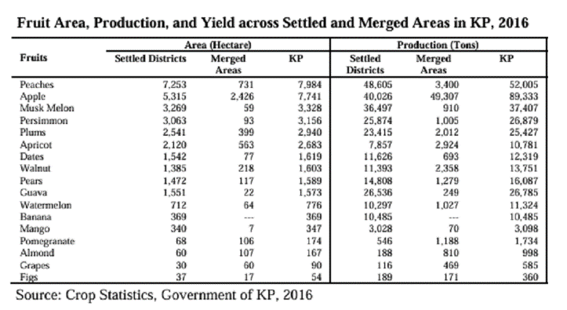In KP, the growing seasons for pulses are Rabi and Kharif. The three most important Rabi pulses are matter (1,403 ha), masoor (2,701 ha), and gram (29,012 ha), which are typically farmed in the rainfed regions of Tank, Kohat, D.I. Khan, Karak, and Lakki Marwt.

**Table 1**: Fruits Yields in KP

**4.2 Brščić Agritourism Model**

There are two main categories of agritourism families, as shown by the model: those involved in tourism and those involved in agriculture. Government protocols especially agriculture and livestock, tourism, etc policies, acts and regulations which demand registrations and operating permissions for every type of agriculture sometimes impose restrictions on the connection between these sectors. This lays up difficulties that prevent tourism and agriculture from blending seamlessly among these homes. The model also emphasizes the considerable effects that agritourism communities may have on the local economy and rural environment, particularly by opening up new markets for regional agricultural producers. In terms of tourism, these families can sell their goods and services directly or indirectly through a variety of channels, such as travel agencies, organizations, and tour operators. By offering extra cash sources and marketing 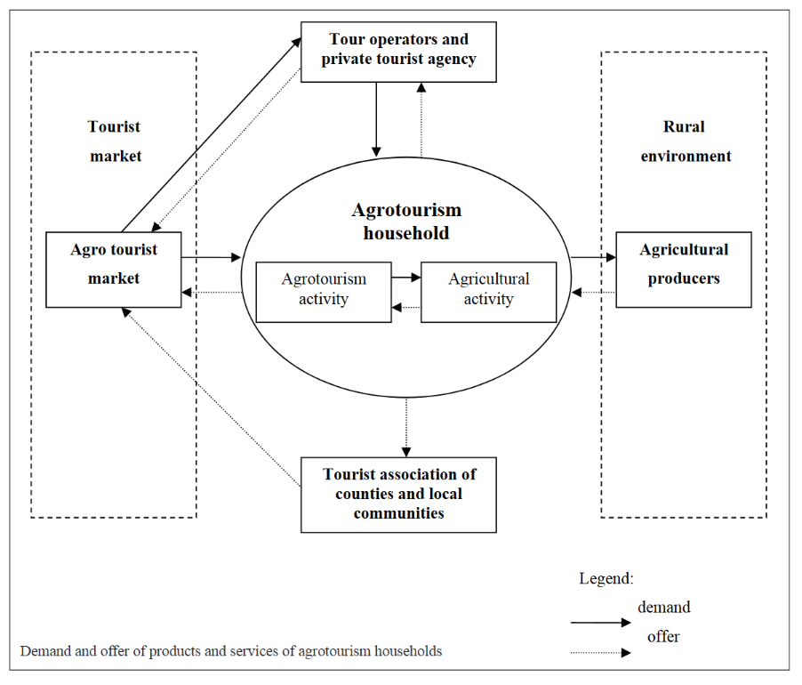local goods to tourists, this dual strategy not only helps agritourism communities but also improves the local agricultural market, which in turn promotes a more sustainable and linked rural economy.

**Figure 4:** Agritourism Model.

(after Brščić, K. (2006). The impact of agrotourism on agricultural production).

**Agritourism activities**

When visiting farms for agritourism, a variety of activities can enhance the experience for visitors, these activities offer a mix of education, recreation, and hands-on experiences that connect visitors with rural life and agriculture including:

* **Farm Tours:** Take a guided tour to discover the farm and get insight into the farm flora & fauna, and agricultural methods.
* **The animals Interaction:** Taking care of goats, sheep, cows, hens etc. by feeding, or milking.
* **Harvesting and Planting:** Taking part in seasonal tasks such as plantation, gathering produce, seedlings, Plucking, packing, the fruits and vegetables.
* **Farm-to-Table Experiences:** Taking culinary lessons or dining on meals prepared with fresh, farm-produced products, preparing salads, beverages, or cooking food.
* **Workshops & Demonstrations:** Gain knowledge and take courses of organic farming, conventional agricultural techniques, biodiversity, conservation techniques, or sustainable agriculture.
* **Outdoor recreation**: This includes things like hiking on farm trails, fishing, pony rides, and Ox cart adventures.
* **Hands-on Crafts:** creating items such as jam, butter, or crafts using agricultural goods.   
  Camping or Farm Stays: Spending the night in cabins, tents, or other agricultural lodging.
* **Lodging:** Agritourism Unique alternatives to hotels include eco-friendly ecolodges designed for sustainability, tree huts with elevated views, and farmstays, where visitors participate in farming operations. Bungalows and campsites offer rustic charm and adventure, while boutique hotels offer luxury with a local flavor. These choices promote cultural interaction and environmentally conscientious travel by immersing visitors in rural living.
* **Food & Beverage service:** A variety of options, Food & Beverage experiences in Agritourism strengthen visitors' ties to rural life. High tea and coffee spots provide calm environments surrounded by natural scenery, showcasing local baked goods and brews. Restaurants and juice corners showcase fresh, farm-to-table ingredients, celebrating regional flavors. Fast food outlets offer convenient menus with a local flair for quick bites. A greater understanding of the local culture and food is fostered by self-selecting and cooking activities, which provide guests the opportunity to choose their own meals and prepare their own meals using fresh produce.

**Table 1:** Some functions and activities in Farms

|  |  |
| --- | --- |
| **Function** | **Activities** |
| **Attractions** | Natural attractions, landscapes, Museums and interpretive centers, Waterfalls, springs, mountains and cultural landscape, Shopping/Souvenir shops |
| **Recreational Activities** | Fishing hut, farm trails/trekking |
| Fruit/Vegetable processing, Fruits, Nuts picking, sowing, harvesting of crops, animals’ interactions, events and festival planning, celebrations |
| Children activities, Rides, livelihood/culture |
| **Factories visit** | Factories visit, Processing units, Packing |

**CASE STUDY**

**Agritourism Development Corporation of Pakistan**

Pakistan is witnessing an increase in the expanding global industry of agritourism. For the past fifteen years, this movement has been led by Mr. Tariq Tanveer, the founder of the Agri-Tourism Development Corporation of Pakistan. The group has run programs such as "Agri Fields Trips" to teach kids about agriculture and agribusiness and to encourage cooperation between farmers, customers, researchers, and entrepreneurs. Additionally, the company hosts national festivals all around Pakistan, promoting local food, traditions, and cultures. These activities boost regional economies and improve ties between rural and urban communities. The company has successfully branded over 100 events, and over 50 more are scheduled. National Kitchen Garden Day, the National Mushroom Festival, the Olive Festival, and the Citrus Festival, Gur Mela, National Tea Festival, etc are noteworthy occasions. To maintain the continuity of each celebration, the Agri-Tourism Development Corporation of Pakistan celebrates important event linked with fruits and vegetable harvesting. In light of the commitment to sustainability and community involvement, which fosters economic development and intercultural exchange throughout Pakistan, these agritourism initiatives will continue to prosper.

**Opportunities for Agritourism in Khyber Pakhtunkhwa**

Agritourism in KP can be leveraged through various opportunities:

1. **Cultural preservation and Educational Experiences**: Numerous advantages of agritourism exist in KP, such as the improvement of rural facilities educational and experiential learning opportunities, economic diversification, sustainable agricultural practices, and cultural preservation. By promoting cultural exchange and teaching about regional farming methods, it can aid in the preservation of cultural heritage.
2. **Economic Diversification & Sustainable Agricultural Practices:** Additionally, agritourism gives farmers a second source of income, lowering their reliance on conventional farming and fostering more resilient and stable rural economies. Farmers can opt for sustainable farming methods like organic farming, agroforestry, and preserving regional plant varieties.
3. **Learning& Enhancing Rural Infrastructure:** It is feasible to offer tourists opportunities for practical and educational learning that will help them develop a greater understanding of rural life and new agriculture practices. Transportation & communication network, lodging facilities, in rural areas are all needed to support the growth of agritourism.
4. **Diverse Agricultural Products**: KP is renowned for its production of various fruits, Several of KP's agricultural products, including Apricot, Apples, Plum, Peaches, citrus fruits, strawberries, and nuts are able to support agritourism endeavors.
5. **Mera Gaon Meri Kahani:** A U-Pick business allows consumers to visit a farm and gather their own fruits, vegetables, flowers, or trees as a direct marketing channel. The potential for U-pick operations, farm stays, and direct sales of fresh produce can attract urban visitors seeking authentic agricultural experiences. For instance, the cultivation of strawberries in Swat and citrus fruits in Haripur can be leveraged to create engaging agritourism activities.
6. **Community Development and Employment**: By generating jobs and involving local families in events, agritourism can also promote employment and community development. Agritourism can be combined with outdoor recreational opportunities to create a more comprehensive visitor experience in KP's scenic landscapes, which include the valleys of Swat, Shangla, Dir, Chitral and Kaghan.
7. **Natural Attractions**: There are numerous many possibilities for outdoor leisure pursuits like self-outdoor cooking, hiking, fishing, and bird watching in the picturesque landscapes of KP, which include the valleys of Dir-Swat, Shangla and Kaghan. The whole visitor experience can be improved by combining these activities with agritourism.

**Creating “Mera Gaon Meri Kahani” initiative**

To illustrate the potential agritourism villages in KP:

**Swat Valley's Fruits Orchards**

In the realm of horticulture, Swat District is well-known for producing a wide variety of mouthwatering apples that are highly sought-after throughout the nation and in certain nearby nations. Additionally, Swat's small-scale bee growers produce high-quality honey that is well-liked by the local populace. Additionally, Swat grows a vast range of peaches, walnuts, figs, pear, apricot, and grapes. Swat Known as the "Switzerland of the East," Swat Valley is well known for its fruit's orchards. In this area, the future agritourism projects have mostly focused on guided orchard tours, farm stays, and fruits-picking festivals. In addition to drawing tourists, these activities give farmers additional revenue. Because of the effectiveness of these programs, progressive farmers are now more inclined to grow a wider variety of crops and use organic farming methods in order to satisfy the needs of health-conscious travelers. A number of farms in Swat have started to provide lodging for guests. Agri- farm stays give visitors a fully-fledged vacation, letting them take part in regular agricultural activities and take in the area's natural splendor. This approach has shown itself to be successful in many countries by improving visitor engagement and bringing in extra revenue.

**Hazara Region's Beekeeping Industry, Tea Tourism. Citrus Fruits**

Hazara is Known for producing honey, walnut farms, trout fishing, Litchi, persimmon, Citrus, Guava, and Loquat etc. Since the inauguration of CPEC, now is ideal to develop Hazara horticultural industry and make it a major "Fruit Supply Hub." Additionally, encouraging agritourism in the area might draw tourists who want to taste fresh food, learn about local fruit farming, and experience farm life. In besides strengthening the local economy, this would also promote sustainable farming methods, open up job opportunities, and introduce a wider audience rich agricultural history.

The opportunity of guided tours, honey extraction workshops, honey tastings, fruit and vegetables are available for visitors. In addition, the initiative helped to promote cooperation and knowledge exchange among the farmers, visitors and experts. Through the combination of tourism and aquaculture, this initiative gives guests the opportunity to engage in recreational fishing while learning about trout farming. These activities boost local revenue and encourage environmentally friendly methods. The fruit festival in Khanpur encourages agritourism by showcasing regional produce and drawing tourists. These festivals celebrate the area's agricultural heritage with a lively atmosphere created by U-pick operations, cooking demonstrations, and local crafts.

**Kohat's Olive & guava Farms**

Within the horticultural industry, Kohat's fruit products are well-known throughout Pakistan. Citrus and guava fruits in particular are thought to be exceptionally tasty and high-quality. Furthermore, bee farming is a common method of producing honey in the district. Compared to many other districts in the province, Kohat's horticultural sector produces a larger amount of supplies each year. Kohat's olive farms are another instance of thriving agritourism in KP.

**Chitral's Fruits Orchards & Trout Farming**

Chitral, located in the northernmost part of KP, is known for its trout farming. Agritourism initiatives here include fishing tours, farm-to-table experiences, and cooking classes. These activities have not only promoted sustainable fishing practices but also provided an alternative income source for local communities.

**Gur festival, Mustard oil & strawberry festival in Mardan Charsadda**

The horticultural industry produces a wide range of fruit and vegetable products. Citrus fruits, oranges, plums, peaches, apricots, and pears are all of high quality. Potatoes, turnips, tomatoes, peas, pumpkins, okra, and beans are all well-known vegetables. It is imperative that Mardan District's horticulture be given a boost in light of the CPEC in KP so that it might develop into a significant to promote “agritourism” for visitors. Fruit Supply Center for neighboring countries like China, Afghanistan, and Central Asia.

Charsadda’s economy has potential to develop in multiple sectors in Agriculture, Dairy, Livestock, tobacco, rice and fish farming. The region of Charsadda-Mardan, which is well-known for producing sugar, can combine agritourism with gur festivals, strawberry festivals, and other events. Gur (jaggery**)** preparation in local "Ghanri" tours with guides, to visit the sugar cane fields, gur production, extraction and variety tastings are available to visitors. A dynamic celebration of regional agriculture, culture, and community can be found in all areas. In Rustom mustard Oil & Oranges Festival. By providing activities like orange capturing and mustard oil pressing demonstrations, such a festival may showcase the area's plentiful produce.

**Linkages between Agritourism and Rural Development**

The case studies above demonstrate the strong linkages between agritourism and rural development in KP. Agritourism has the potential to:

* **Enhance Local Economies:** By providing additional income streams and creating employment opportunities, agritourism can significantly boost local economies.
* **Promote Environmental Conservation:** The focus on sustainable agricultural practices within agritourism can lead to better land management, biodiversity conservation, and reduced environmental degradation.
* **Foster Social Cohesion:** Agritourism encourages community involvement and collaboration, fostering social cohesion and a sense of shared identity among rural populations.
* **Preserve Cultural Heritage:** Agritourism activities often revolve around traditional practices and customs, helping to preserve and promote cultural heritage.
* **Collaboration with Local Governments & NGO**: • Local government support can help farmers interested in agritourism by facilitating marketing, training programs, and infrastructure development. Collaborations with non-governmental organizations can be extremely helpful in promoting agritourism by helping establish infrastructure associated with tourism, offering training in handling hospitality operations, and launching strengthening capacities.
* **Networking with Tourism Agencies**: Collaborating with tourism agencies can help promote agritourism destinations in KP, attracting both domestic and international tourists.

**CHALLENGES AND RECOMMENDATION**

Despite its potential, agritourism in KP faces several challenges. Agritourism encounters various obstacles such as inadequate infrastructure, limited government support, seasonal activities, lack of training in hospitality and marketing, lack of awareness and training among farmers and local communities, and regulatory barriers. These elements support the expansion of agritourism, which may cause farmers' incomes to fluctuate. To encourage the growth of agritourism, investments in rural infrastructure are essential. Tax free loans, training, Investment model, business models, subsidies, and other forms of government assistance other incentives may also be helpful. Income can also be impacted by seasonality, which makes diversifying agritourism offerings necessary. Inadequate communication and transportation systems can also restrict the number of visitors. Farmers interested in expanding their sources of income through tourism may encounter uncertainty due to regulatory barriers.

**CONCLUSION**

Agritourism is a subset of rural tourism that involves guests are welcomed on farmland for engagements in agriculture occasions, provided with overnight stays, and entertained with organic menu. Agritourism offers a promising opportunity for economic diversification and community development in Khyber Pakhtunkhwa. By leveraging its agricultural diversity, cultural heritage, and natural beauty, KP can develop a robust agritourism sector that benefits local communities and enhances the overall tourism experience. Additionally, because multidisciplinary collaboration for finance and the formulation of policies is lacking in developing nations, the engagement of small enterprises may help in the growth of agritourism in the rural economy (Khairabadi, O., et al., 2020). Addressing the challenges through collaboration, training, and infrastructure development will be essential for realizing the full potential of agritourism in the region.

Agritourism in Khyber Pakhtunkhwa holds immense potential for fostering sustainable rural development, preserving cultural heritage, and enhancing the livelihoods of local communities. The case studies presented in this article demonstrate the positive impact of agritourism on local economies and agricultural practices. However, to fully realize this potential, there is a need for greater awareness, improved infrastructure, and targeted government support. By addressing these challenges, KP can become a leading destination for agritourism in Pakistan, offering unique experiences for tourists while supporting the region's agricultural and rural development.

**REFERENCES**

[Barbieri, C.](https://www.emerald.com/insight/search?q=Carla%20Barbieri) (2020),"Agritourism research: a perspective article*",*[Tourism Review](https://www.emerald.com/insight/publication/issn/1660-5373)*,* Vol. 75 No. 1, pp. 149-152. <https://doi.org/10.1108/TR-05-2019-0152>.

Barbieri, C., & Mshenga, P. M. (2008). The role of the firm and owner characteristics on the performance of agritourism farms. Sociologia ruralis, 48(2), 166-183.

Brščić, K. (2006). The impact of agrotourism on agricultural production. Journal of Central European Agriculture, 7(3), 559-563.

Chaiya, C., Sikandar, S., Pinthong, P., Saqib, S. E., & Ali, N. (2023). The impact of formal agricultural credit on farm productivity and its utilization in Khyber Pakhtunkhwa, Pakistan. Sustainability, 15(2), 1217.

Choo, H., & Park, D. B. (2022). The role of agritourism farms’ characteristics on the performance: A case study of agritourism farm in South Korea. International Journal of Hospitality & Tourism Administration, 23(3), 464-477.

content/uploads/2017/02/00_History_Dev_of_A. gritourism.pdf (access 11.10.2024).

Karabati, S., Dogan, E., Pinar, M., & Celik, L. M., (2009). Socio-economic effects of agri-tourism

Khairabadi, O., Sajadzadeh, H., & Mohamadianmansoor, S. (2020). Assessment and evaluation of tourism activities with emphasis on agritourism: The case of simin region in Hamedan City. Land Use Policy, 99, 105045

Khanal, A. R., Honey, U., & Omobitan, O. (2020). Diversification through ‘fun in the farm’: Analyzing structural factors affecting agritourism in Tennessee. International Food and Agribusiness Management Review, 23(1), 105-120.

Khyber Pakhtunkhwa Crop Statistics, 2018-19. Available at: http://Khyber Pakhtunkhwa.gov.pk/uploads/2020/08/CROP_ STATISTICS_2018-19.pdf

Krishna, D. K., & Sahoo, A. K. (2020). Overview of agritourism in India and world. Food and Scientific Reports, 1(7), 56-59

Lak, A., & Khairabadi, O. (2022). Leveraging agritourism in rural areas in developing countries: The case of Iran. Frontiers in Sustainable Cities, 4, 863385.

McGehee, N. G., & Kim, K. (2004). Motivation for agri-tourism entrepreneurship. Journal of travel research, 43(2), 161-170.

Miller, V., Giles, J., Khan, M., Mumtaz, H., Savelli, A., & Grosjean, G. (2021). Climate-smart agriculture in Khyber Pakhtunkhwa, Pakistan. CSA Country Profiles for Asia.

Naveed, S, (2024). Khyber-Pakhtunkhwa Has Witnessed A Tourism Boom Over The Past Year, Fridaytime <https://thefridaytimes.com/> access 30.8.2024.

on local communities in Turkey: The case of Aglasun. International Journal of Hospitality &

Phillip, S., Hunter, C., & Blackstock, K. (2010). A typology for defining agritourism. Tourism management, 31(6), 754-758.

PTDC (2024). Pakistan Tourism barometer, 2023-24, Pakistan Tourism Development Corporation Islamabad Pakistan.

Saqib, S. E., Khan, H., Panezai, S., Ali, U., & Ali, M. (2017). Credit Fungibility and credit margin of investment: the case of subsistence farmers in Khyber Pakhtunkhwa. Sarhad Journal of Agriculture, 33(4), 661-667.

Tanveer, Tariq (2024) Atd, <https://www.facebook.com/atdccom/> access (10/9/2024).

Tchetchik, A., Fleischer, A., & Finkelshtain, I. (2008). Differentiation and synergies in rural tourism: Estimation and simulation of the Israeli market. American journal of agricultural economics, 90(2), 553-570.

Torres, R., & Momsen, J. (2011). Tourism and agriculture: new geographies of consumption, production and rural restructuring. Routledge.

Tourism Administration, 10(2), 129-142.

Travelogegon (2017). A Brief History of Agritourism, Internationally and in the United States. <https://industry.traveloregon.com/wp>

Veljković, B., & Broćić, Z. (2017, June). Agritourism and rural development. In Tourism International Scientific Conference Vrnjačka Banja-TISC (Vol. 2, No. 2, pp. 480-499).

Yinga, T., & Zhou, Y. (2007). Community, governments and external capitals in China’s rural cultural tourism: A comparative study of two adjacent villages. Tourism Management, [28](https://doi.org/https:/doi.org/10.1016/j.tourman.2005.12.025)([1](https://doi.org/https:/doi.org/10.1016/j.tourman.2005.12.025)), 96–107.